Paypal Payment Checkout Configuration

- Goto https://developer.paypal.com/dashboard/applications/sandbox
- Copy ClientId and Secret here
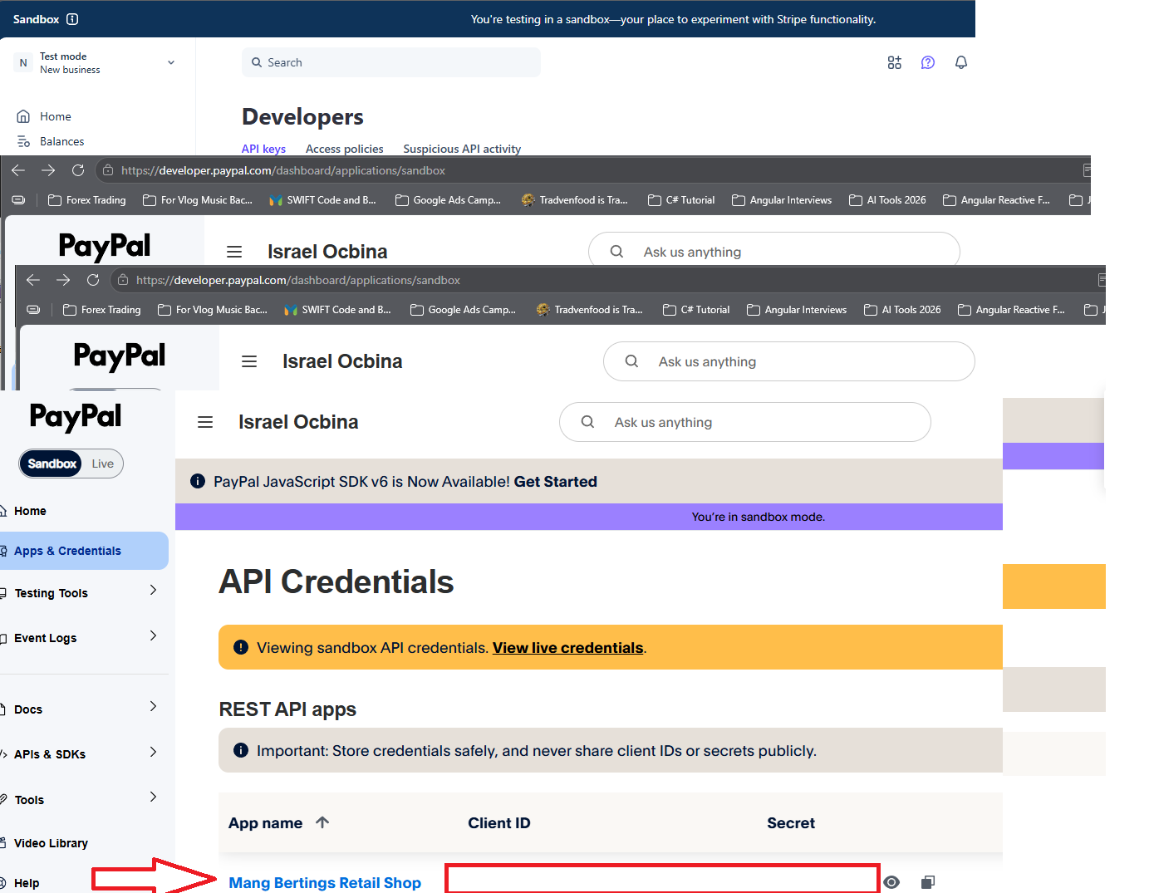

- Create Webhook
